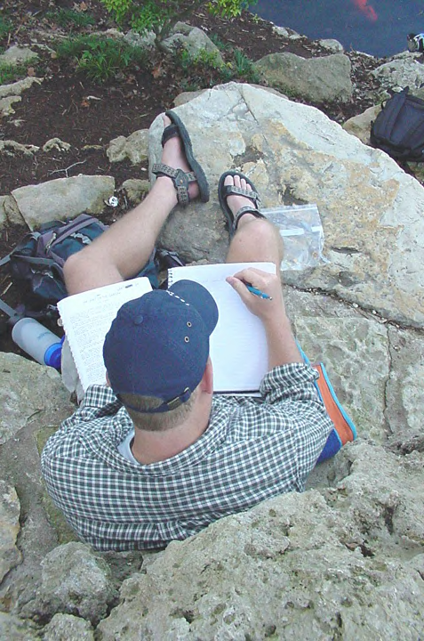
Michael Osborne
E320M
Jerome Bump
2/20/03

Transcription of Taniguchi Garden Journal

This garden communicates to me as Taniguchi intended it to: as “a symbol of universal peace (pg. 84).” I can’t imagine a struggle or a fight ever taking place here. There is something simple and small about the beauty here. Nothing seems large or intrusive. Nothing feels competitive. The garden is as Taniguchi says, “the embodiment of the peaceful coexistence of all the elements of nature (pg. 84).” Even the fish seem willing to share the scraps of food I am feeling them. There is a sweet blend of harmony and peace inside the walls of the garden.
But, I can here Mopac and the recurring bumps of the cars going over the bridge over Town Lake. It reminds me that this garden is an island. I’ve never been very religious, but the idea of a Garden of Eden has always intrigued me. Was there a time when the world was a garden? Did we live on a globe where everywhere it could feel like it does in here? Have we lost something in our pursuit of knowledge, and are we still losing it?
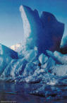
I think the water is purifying here, as clear water is everywhere. Once, when I was backpacking in Chile, our group hiked out to a glacier. We were walking around on a sea of ice. Here and there you could see sky blue puddles of water where the midday sun had begun to melt the ice. In some spots the polls had grown and the water trickled further and further into the glacier creating caves and underground rivers and waterfalls. I walked up to a pool that was probably about a foot in diameter; it had formed quite recently. I made to do a push-up to drink from the pool, and before my lips touched the surface it occurred to me that this water had never been touched. No creature, including man, has ever seen or used this water; there is little to no life on a glacier. As I drank the frigid water I felt a shot go through me all the way to my toes. It was purity that my body now knows. That water will always be inside my blood and my heart. After I drank I felt cleansed and invigorated. I still feel that way thinking about it now.
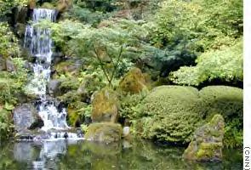
Water as a symbol of purity coincides with the feelings of harmony. It is the one thing that is essential to all living things. I think that that is what the peace in the garden is all about; that is, it’s a peace between man and nature. So often we consider natural forces as something that we need to control, or try to get a hold of. In the garden we control some things, but we also allow nature to do what it will. The garden represents to me a sort of truce, and from that truce arises the feeling of peace.

