Dogs Hurting the Most Have a Special Place to Heal
By COREY KILGANNONOCT. 1, 2015
Photo
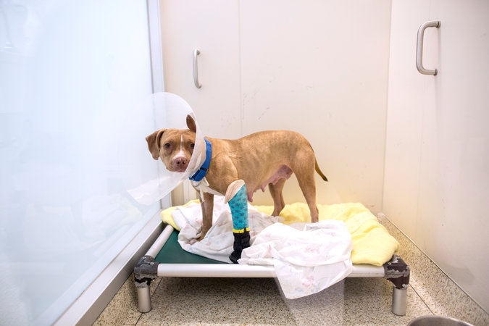
Kix, a 3-year-old pit bull mix who was found wounded and tied to a pole in the Bronx, is treated at a center run by the American Society for the Prevention of Cruelty to Animals. CreditBrian Harkin for The New York Times
Continue reading the main storyShare This Page
- Email
- Share
- Tweet
- Save
- More
Alvin, a young pit bull mix, tensed up when a strangely dressed woman burst into the animal playroom.
He began to bark, but calmed down as the woman walked in and out of the room, wearing various disguises and tossing him treats whenever he stayed calm. The woman, Victoria Wells, was an animal behaviorist who had been working with Alvin for weeks. When she removed her costume, the dog stood on his hind legs and embraced Ms. Wells, licking her excitedly.
Alvin is a patient at a new center in New York City designed to handle the most horrific cases of animal abuse — dogs that have been shot, beaten, burned or malnourished to the point of blindness — and to rehabilitate the nearly broken animals, giving them a chance for a healthy life with a caring family.
The American Society for the Prevention of Cruelty to Animals opened the center to handle an increase in the number of dog cruelty cases it says it has received since dissolving its small enforcement unit last year and shifting its enforcement duty to the New York Police Department.
Photo
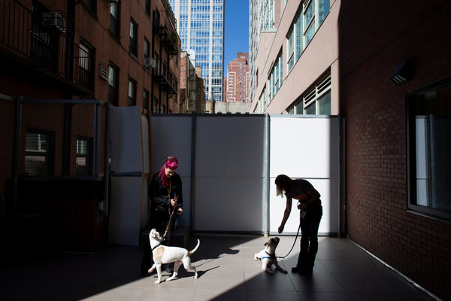
Victoria Wells, an animal behaviorist, left, and Joanne Langman, a behavior counselor, lead Angus and Brahma, 1-year-old boxer mix brothers, through a social skills exercise.CreditBrian Harkin for The New York Times
Many of the dogs brought to the center arrive so traumatized that they cannot safely be put up for adoption.
“A lot of these dogs would very likely be euthanasiacandidates, because they have been so badly abused, if they were not given the time and resources they need to heal,” said Matthew Bershadker, the president of the society.
The center provides “a lifesaving program” for many of the dogs, Mr. Bershadker said, noting that its comprehensive approach has attracted interest from other humane organizations around the country.
When Alvin arrived at the center, on the Upper East Side of Manhattan, three months ago, he was so emaciated and weak that he could not walk.
His owner was charged with torturing and injuring him, and Alvin was nursed back to physical health, society officials said. Emotional scars remained, however, including an aversion to people he did not recognize, as well as unfamiliar clothing or objects.
But over the course of many sessions, Ms. Wells has taught Alvin to trust people he does not know. His progress has been heartening to Ms. Wells, who uses a variety of outfits, including things like a bright yellow raincoat and a straw hat. Dogs like Alvin “come in broken and hopeless and they leave happy and healthy,” she said.
Society officials said they began the police partnership with the hope of it would carry wider enforcement. A.S.P.C.A. workers have conducted training at the Police Academy on subjects such as animal cruelty laws, forensic investigation, pet hoarding and blood sports, like dogfighting.
The transfer of enforcement responsibilities has led to a surge in the number of animals being rescued and in the number of people arrested on charges of mistreatment, society officials said.
From 2013 to 2014, the number of abused animals, most of them dogs, handled by the society increased to 422 from 133, with arrests in cruelty cases rising to 134 from 42, according to the organization. The increase has been even sharper this year, with more than 560 animals taken in by the end of September, and more than 125 arrests.
The A.S.P.C.A. has taken in more dogs that “would have languished, suffered and probably died alone by themselves as a result of abuse and neglect,” Mr. Bershadker said.
Photo
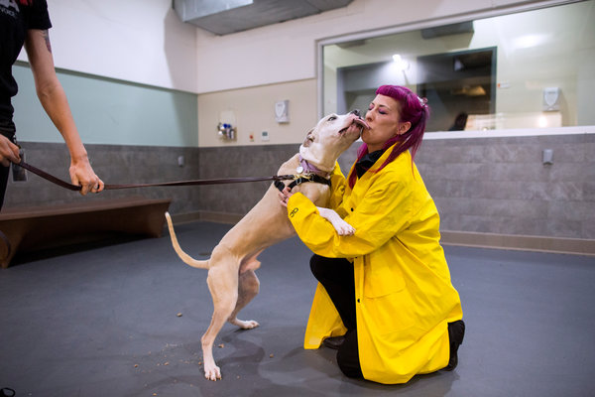
Ms. Wells wears a costume to test the reaction of Alvin, a 3-year-old pit bull mix found in the Bronx, to strangers. Alvin’s owner was charged with torturing and injuring him.CreditBrian Harkin for The New York Times
At the center, dogs receive immediate emergency medical treatment, postoperative rehabilitation and long-term therapy with workers trained to treat psychological and behavioral issues.
Since traumatized dogs often respond poorly to standard kennel conditions, the center features larger rooms, equipped with special features that make feeding and cleaning possible without handlers having to enter a dog’s individual space.
There is a spa-meets-hospital feel. Soundproofing and light dimmers are used to minimize disruption. Calming scents and music enhance the daily exercises, which are conducted by specialists that meticulously document each dog’s condition and progress. This is, in part, to provide evidence in the prosecution of abusive owners.
Mr. Bershadker ticked off a list of the center’s early cases, involving pets he called “betrayed by humanity.” There was Fraggle, a pit bull mix starved nearly to death, locked inside a suitcase and left on the street. There was Lacey, a puppy beaten with a shovel and buried in the snow. There was the dog who survived being shot in the head.
“They’ve never really been dogs — they never chased a ball, never had their tummies rubbed,” he said. But, he added, each of those three dogs has now found a new home.
The center gives its animals a chance to “enjoy life as a dog, maybe for the first time,” Mr. Bershadker said.
During a recent tour, Mr. Bershadker strolled through the society’s intensive care unit, where dogs are often first treated. It is a bustling medical triage area not unlike a hospital emergency room.
Veterinarians and technicians examined and treated animals reduced to skin and bones. On one surgical table, two technicians in blue scrubs carefully shaved the matted fur, a frequent result of severe neglect, off a Maltese mix that had been rescued by police officers.
In addition to sustaining physical wounds, many of the dogs have been concurrently deprived of proper socialization, so that “even getting petted might be new to them,” Mr. Bershadker said.
After medical treatment, the dogs often undergo initial behavioral treatment and screening, which can include tests involving dolls, fake dogs or props such as wheelchairs to gauge how they might respond to new homes and urban living.
Photo
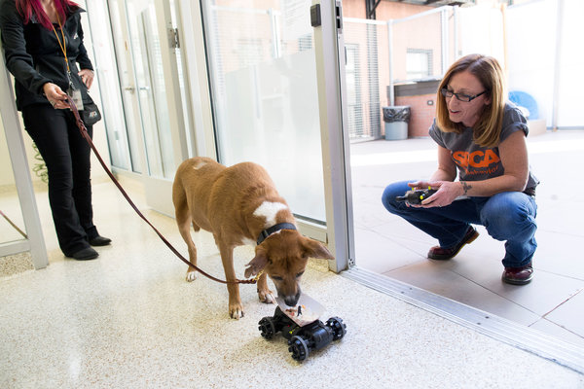
Ms. Langman observes Crimson, a blind 7-year-old shepherd mix, as he walks toward a dish of food pulled by a remote-controlled car at the hospital. CreditBrian Harkin for The New York Times
On this particular day, employees were working with Angus, a young boxer mix found in July, emaciated and tied to a tree. He was brought in unable to stand, said Dr. Lindsay Thorson, a veterinarian at the center. Angus was having trouble getting along with other dogs. A staff member held him on a leash, rewarding him with a treat each time he made eye contact with another dog when it was walked by.
Then it was training time for Crimson, a shepherd mix so neglected — he was found with five others abandoned in the Bronx, without food, water or shelter — that he had gone blind.
Staff members put his food dish on a remote-controlled car and slowly lured him to an outside play area. The idea was to induce Crimson into using smell and hearing to follow the car and move around the center.
To be adopted, Crimson would need to be matched with owners willing to care for a dog with severe challenges, said Kris Lindsay, an operations manager.
The disheartening details of their abuse begin to fade when the animals finally reach the point where A.S.P.C.A. workers believe they are suitable for adoption, Mr. Bershadker said. A handful of dogs, however, do not improve enough and are considered dangerous to humans or other dogs. They must be euthanized, he said.
The dogs are often chosen for adoption by people with the compassion to deal with lingering vulnerabilities, as in the case of Beezus, a 3-year-old pit bull rescued by the police in January with signs of grave abuse. Those signs included a large, bloody gash on her head, most likely a stab wound.
Beezus was initially frightened around strangers, but became very affectionate after several visits from the same person, said Molly Rodau McCarey, 28, of Brooklyn, who along with her husband, Daniel McCarey, adopted Beezus after bonding with her at the A.S.P.C.A.’s adoption center over the course of a week.
“We saw something in her that just connected with us, and we thought she deserved another chance,” Ms. Rodau McCarey said. “I’d like to believe that whoever put her in harm’s way, that it wasn’t malicious and that they had their own struggles.”
Regarding Beezus’ painful past, she said, “I can let bygones be bygones and focus on her new life, because so many pit bulls don’t get a second chance.”
As Mr. Bershadker looked around the center, he said the care provided there is expensive, “but this is exactly what these animals deserve.
“We owe these animals because we, as a society, as a species, have so horribly betrayed them and failed them,” he added. “It’s our responsibility to make sure they live the life they were born to live.”
A version of this article appears in print on October 2, 2015, on page A23 of theNew York edition with the headline: Dogs That Hurt the Most Now Have a Special Place to Heal. Order Reprints| Today's Paper|Subscribe

